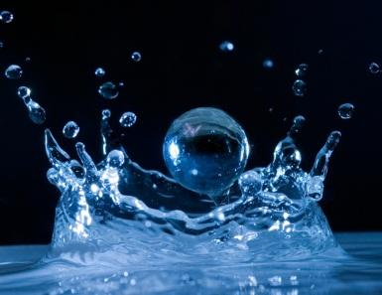
WATER – A Closer Look at Current Issues
A jigsaw activity

Freshwater is a limited resource on Earth. The distribution of fresh water is unequal and the technologies to clean polluted water are not available in all nations. People in different nations use water for different tasks and events which influences the importance they put onto fresh water availability. As we explore freshwater issues around the globe, we will be able to appreciate different perspectives about fresh water.

Activity
- Each person will be assigned one of 8 articles from the April 2010 National Geographic Water: Our Thirsty World issue to read and summarize.
- All members reading the same article will come together to develop their summary. The purpose of reading the article is to summarize the main idea(s) of the article for your classmates. Each article has so much “juicy” information in it about current water issues; we just don’t have the time to read each article individually, so we will share the main points so we have a working knowledge of each article to help enhance our understanding of water resources.
- As an expert group, please view the short video segment related to your article (see the website for the link). It may enhance your summary.
- As an expert group, create a google presentation that incorporates the summary you developed and enhances the summary using relevant pictures and/or graphics. Be sure to share the presentation with all members of your expert group.
- The class will then form 2 – 3 groups, with representatives from each article. In these groups, each article expert will share their presentation with the group.
- It is a good idea to take notes as you listen to each presentation so that you can refer to them when answering the discussion questions.

Link to April 2010 Nat Geo - http://ngm.nationalgeographic.com/2010/04/table-of-contents
Link to April 2010 Nat Geo Videos - http://ngm.nationalgeographic.com/video/player#/?titleID=water-thirsty-world&catID=1

Articles:
Silent Springs – http://ngm.nationalgeographic.com/2010/04/freshwater-species/chadwick-text
Sacred Waters - http://ngm.nationalgeographic.com/2010/04/sacred-water/newman-text
Freshwater Crisis –
The Burden of Thirst –
Parting the Waters
Thirsty World
Plumbing California
The Last Drop
Get The Salt Out
Tibetan Plateau

Name________________________Period_________________Date________________________

WATER – A Closer Look at Current Issues
Discussion Questions

Please answer the questions below in full detail using your notes taken during the jigsaw activity.

- Relate the Silent Springs article to environmental indicators. Be sure to define environmental indicator and describe what the organisms are trying to tell us about the water.

- In reference to the Sacred Waters article, discuss the significance water has played in your life.

- Imagine that the United States was similar to Kenya. Discuss how the lack of clean water would affect your daily life.

- Describe the role that water plays in the lives of women in developing countries. Relate this to the UN’s Millennium Goals.

- Choose an issue discussed in one of the articles that had the greatest impact on you. Explain how the article affected you and how it has changed your perspective about fresh water availability.

- Extension – Research a country or culture not discussed in the article, The Burden of Thirst, where women and/or children are relied on for getting water. Describe their daily lives and how the lack of available fresh water is preventing them from getting out of poverty. Research a program that is in place (does not have to be in the country you research) to help bring fresh water resources to these types of areas. Describe the program and why it is important to help reduce poverty in these areas.

