Day 1 - Matter, Atom and Periodic Table Review
- Explain the difference between homogeneous and heterogeneous matter. Give an example of each.
- Explain the difference between a pure substance and a mixture. Give an example of each.
- Describe each of the following mixtures:
- Solution
- Suspension
- Colloid
- What are the states of mater?
- Complete the following by naming the phase change

- Solid to Liquid
- Liquid to Solid
- Liquid to Gas
- Gas to Liquid

- Describe the following

- Saturated
- Unsaturated
- Supersaturated
- Electrolyte
- Nonelectrolyte
- Solute
- Solvent

- Label the following phase change graph
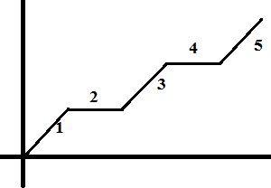
- What is the difference between boiling and evaporation?
- What is the difference between endothermic and exothermic?
- A block of wood has the measurements of 3-cm by 6-cm by 4-cm. That same block of wood has a mass of 80 grams. What is the density of the wood?
- How do you find the following
- Protons
- Neutrons
- Electrons
- Describe an isotope. How would Oxygen-16 differ from Oxygen-17?
- What are periods and what do they represent on a aton?
- Match the following: proton, proton and neutron, electrons in outer shell, electrons elements will gain or lose

- Atomic Number
- Mass Number
- Valence Electrons
- Oxidation Number

- Where are metals locate on the periodic table?
- Where are nonmetals located on the periodic table?
- Draw the Electron Dot Diagram for Aluminum and the Bohr model for Sulfur.

- Complete the following chart
Element | # of Protons | # of Electrons | # of Neutrons | Valence Electrons | Oxidation Number | Metal, Nonmetal or Metalloid
Helium
Boron
19. This graph shows temperature vs. energy data for a substance. What is the melting point of this substance?
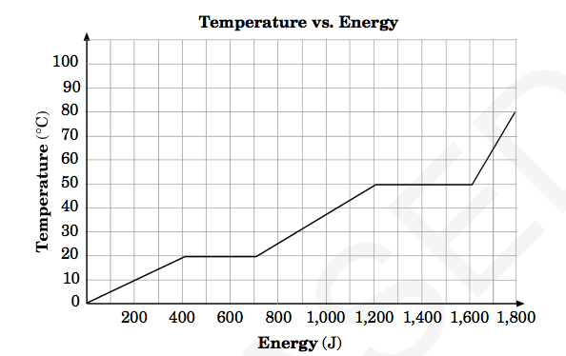
20. This graph shows the solubility curves for various ionic compounds. Which compound is most affected by a change in temperature from 30C to 50C?
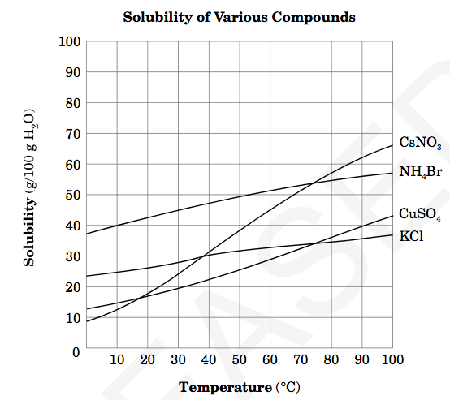
21. This diagram shows a marble with a mass of 3.8 g that was placed into 10 mL of water. What is the density of the marble?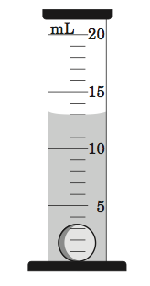
22. Which elements are in the same period? (Circle) lead and sodium , oxygen and helium, silver and tin, or tin and lead
23. This chart lists the densities of various gemstones. A gemstone has a mass of 6.24 g and a volume of 1.98 cm3. What is the identity of the gemstone?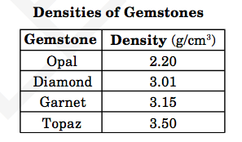

Day 2 - Periodic Table and Chemical Bonding Review
- What are valence electrons?
- What are oxidation numbers?
- Elements in the same period have what in common?
- Elements in the same group have what in common?
- Multiple Choice: Which of the following metals is more reactive than magnesium?

  - Aluminum
  - Calcium
  - Copper
  - Zinc

- What are the three classifications of elements and where are they on the periodic table?
- What is the difference between an Ionic Bond, Covalent Bond and Metallic Bond
- For the following, tell what type of bond they are and why they are that type of bond?

- NaCl
- CO
- KI
- SiF₄

- Multiple Choice: Which combinations of elements will form an ionic bond?

- Carbon and Hydrogen
- Chlorine and Magnesium
- Chlorine and Fluorine
- Hydrogen and Oxygen

- What is the difference between a Binary Compound and a Polyatomic Compound?
- How would you name a Binary Ionic Compound? Binary Covalent Compound? Polyatomic Compound?
- For the following, name the compound? (Don’t tell if it is binary or polyatomic.)

- MgF₂
- KNO₃
- P₄S₅
- Al₂(SO₄)₃

- How would you write the formula for an Ionic Binary Compound? Polyatomic Compound? Covalent Binary Compound?
- For the following, write the formula.

- Aluminum and Phosphate
- Sulfur trioxide
- Magnesium Hydroxide
- diphosphorus pentoxide

- Multiple Choice: What is the correct chemical formula for Magnesium phosphate?

- Mg₃P
- MgPO₄
- Mg₃PO₄
- Mg₃(PO₄)₂

- Multiple Choice: Which pair of elements are most similar?

- Ca and F
- Na and Cl
- Ne and Ar
- Li and H

- Mutiple Choice: The compound formed from the elements calcium and chlorine is known as

- Chlorine calcide
- Calcite
- Calcium chloride
- Calcium chlorate

- What subatomic particle is shared when two atoms react chemically?
19. Which chemical formula represents magnesium phosphate? A MgPO4 B Mg2PO4 C Mg3 PO4 2 D Mg₂PO₄₃
- Which element has the same number of valence electrons as krypton (Kr)? (Circle) neon (Ne) fluorine (F) chlorine (Cl) selenium (Se)
21. An atom has 29 protons, 29 electrons, and 35 neutrons. What is the mass number of the atoms?
22. Which element is an alkaline earth metal? (Circle) Li O Ne Ca
23. What particles account for most of the mass of an atom?
24. How many protons and neutrons are there in an atom of 115 B ?
25. What statement would best describe the atoms of elements that form compounds by covalent bonding?
26. Which compound is most likely formed using covalent bonds? A SiO2 B K2O C KBr D CaBr ₂
Day 3 - Chemical Reactions, Acids, Bases, and Nuclear Chemistry Review
- What are the two parts of a chemical equation and how do they differ?
- What is the difference between endothermic reactions and exothermic reactions?
- What are some signs of a chemical reaction?
- For the following, count the number of atoms for each element and the total number of atoms present.
  - 4CO₂
  - 2Mg(OH)₂
- Multiple Choice: Which of the following contains the most atoms?

  - K₂MnO₇
  - Al₂(SO₄)₃
  - C₄H₄F₄Cl₂
  - Hg₂(NO₃)₂

- For the following, balance the chemical reactions.
  - N₂ + O₂ → N₂O
  - KI + Cl₂ → KCl + I₂
- Multiple Choice: What is the coefficient of iron (Fe) when the following chemical equation is balanced? Fe+Cl₂→FeCl₃

  - 1
  - 2
  - 3
  - 4

- Multiple Choice: Which equation below is correctly balanced?

- 2Na + O₂ → 2Na₂O
- Sn + 2KOH → K₂SnO₂ + H₂
- AsCl₃ + 3H₂O → 3HCl + As(OH)₃
- H₂ + O₂ → H₂O

- How do you determine which of the following reaction types is present
  - Synthesis
  - Decomposition
  - Neutralization Reaction

  - Single Replacement
  - Double Replacement
  - Combustion

- For the following, identify which of the main types of reactions the equation is representing.
  - 2KClO₃ → 2KCl + 3O₂
  - HCl + NaOH → NaCl + H₂O
  - Mg + 2HCl → MgCl₂ + H₂
  - 2H₂ + O₂ → 2H₂O
  - 2Al + 3NiBr₂ → 2AlBr₃ + 3Ni
  - 4Al + 3O₂ → 2Al₂O₃
  - 2NaCl → 2Na + Cl₂
  - CaCl₂ + F₂ → CaF₂ + Cl₂
  - AgNO₃ + KCl → KNO₃ + AgCl
- What are the properties of an Acid?
- What are the properties of a Base?
- Identify the following as an Acid or a Base or a Salt

  - HNO₃
  - NaOH
  - NaNO₃
  - HCl
  - KCl
  - Ba(OH)₂
  - KOH
  - H₂S

- Explain the laboratory observations that could be used to determine if a substance is an acid or a base.
- What is the pH scale and explain the ranges for an acid and a base.
- Multiple Choice: Which pH would indicate the most acidic substance?

  - 2
  - 4
  - 10
  - 14

- Explain the difference between an Alpha Particle, Beta Particle, and Gamma Ray.
- Write out the alpha decay of Uranium—238?
- Write out the beta decay of Carbon—14?
- Multiple Choice: Which type of naturally occurring radioactivity results in an increase in atomic number of an atom?

  - Fusion
  - Alpha decay
  - Beta decay
  - Gamma rays

- Compare and Contrast nuclear fission and nuclear fusion.
- Multiple Choice: A radioactive isotope of iodine has a half-life of 8 days. What amount of an 80-gram sample would remain unchanged after 24 days?
  - 10 grams
  - 20 grams
  - 30 grams
  - 40 grams
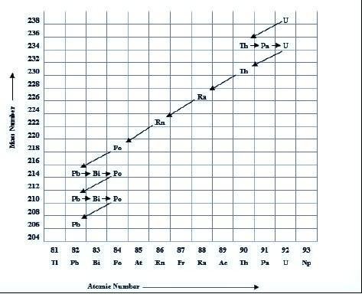
- Multiple Choice: For this question, use the chart at the bottom of the page. What particles are the products of the natural radioactive decay of an atom of uranium—238?
  - Thorium—234 and an alpha particle
  - Radium—226 and an alpha particle
  - Uranium—234 and a beta particle
  - Polonium—218 and a beta particle

DAY 4 - Motion, Force, Work, and Power Review Sheet
- Alex rode his motorcycle 600 meters in 15 seconds. How fast did he go?
- Jessica ran at a speed of 5.5 m/s for a total of 120 seconds. How far did she go?
- A car starts from rest and goes to 20 m/s in 4 seconds. What is the car’s acceleration?
- A runner is going at a speed of 5 m/s and increases her speed to 55 m/s in a time of 25 seconds. What is the runner’s acceleration?
- At the end of a race, a sprinter with a mass of 80 kg has a speed of 10 m/s. What is the sprinter’s momentum?
- Explain how two objects could have the same momentum. The first object has a mass of 1-kg and the second object has a mass of 10-kg.
- How can a feather and a rock fall at the same rate?
- How much does a 125 kg object weigh on Earth?
- If a 20 kg zombie is on Earth, how much does it weigh?
- Explain the four types of friction. Static, rolling, fluid, and sliding
- What is Newton’s first law of motion?
- What is the second law of motion?
- How much force is needed to accelerate a 500 kg car at a rate of 4 m/s/s?
- What is the third law of motion and how is it used?
- A motorcycle does 2000 J of work in 25 seconds. How much power is produced?
- Beth moved a 20 N walker 20 meters in 10 seconds. How much power was required to perform the action?
- How much power is required to lift a 2.0-kg object, 5.0 meters in 4.50 seconds?
- This diagram shows three horizontal forces acting on an object. Neglecting friction, what is the magnitude of force, F, if the object remains at rest? A 6 N B 8 N C 14 N D 22 N
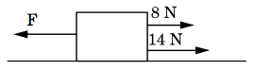
- This graph represents the velocity of an object over time. What is the average acceleration of the object during the first 4 seconds? A 1 m/s/s B 2 m/s/s C 4 m/s/s D 8 m/s/s
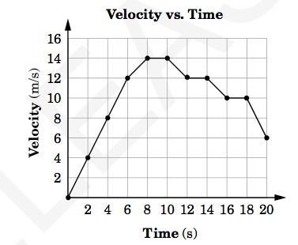
20. A large rock has a mass of 750 kg. What is its weight?
21. This graph shows the motion of a car. What distance has the car traveled in 10 s?
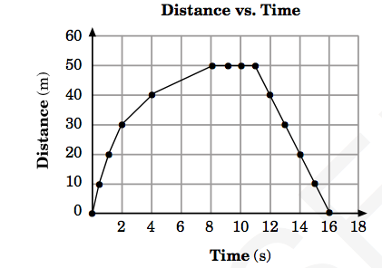

22. This diagram represents a balloon that is moving in one direction while escaping air is moving in the opposite direction.
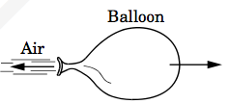 What causes the balloon to move?
23. A car’s velocity changes from 0 m/s to 40 m/s in 5 seconds. What is the average acceleration of the car?
24. A quarter is resting on top of an index card, which has been placed across the top of a small cup.
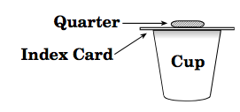When the card is given a hard horizontal push to the right, what will happen?
25. How much power is used to lift a box that weighs 50 newtons 10 meters in 10 seconds?
26. If 15 N of force are applied to a cart to move it a distance of 5 m, how much work is done on the cart?
27. This diagram shows an object being pushed along a frictionless surface. The object accelerates at 2 m/s/s.
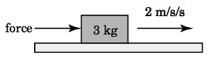What force was applied to the object?

Day 5 - Energy, Heat, Waves, Electricity, and Magnetism
- What is the difference between kinetic energy and potential energy?
- What is the kinetic energy of an 8-kg object that is moving at a speed of 4 m/s?
- What is the potential energy of an 8-kg object that is seating at the top of a 4 meter hill on Earth?
- What does the law of conservation of energy state?
- How does heat flow?
- Name the three ways heat is transferred and describe them.
- Multiple Choice: Which of the following occurs as a pot of soup on a hot burner begins to boil?
- Thermal energy is not transferred
- Thermal energy is transferred from the burner to the air to the soup.
- Thermal energy is transferred from the burner to the pot to the soup.
- Thermal energy is transferred from the soup to the burner.
- What is the difference between a conductor and an insulator?

- Multiple Choice: Why does a metal spoon feel colder to the touch than a wooden spoon at the same temperature?
- Metals have a lower boiling point than wood.
- Metals transfer more thermal energy
- Wood is a better reflector of radiant energy
- Wood has less mass than metal
- What happens to objects as they are given more heat and the temperature rises?
- Multiple Choice: Which statement is true for all types of waves?
- Wave speed is determined by the frequency
- Wave speed increases as the wavelength of the wave increases
- Wave motion transports particles of matter
- Wave motion transfers energy from one place to another
- Give an example of the following
  - Transverse wave b. Longitudinal wave c. Surface wave

- What is frequency and how do you determine it?
- Multiple Choice: Which type of wave would be classified as compressional?
- Visible light
- Ultrasound
- X-rays
- Radio waves
- What is the effect on frequency of a wave when the wavelength is doubled?
- Explain the four basic wave interactions.
- Which wave interaction best explains glares on the windshield of a car?
- The bending and change in speed of water waves as they approach a shoreline is explained by what process?
- List the waves of the electromagnetic spectrum from longest to shortest wavelength.
- A student noticed that woolen sweater was clinging to a silk scarf. Why would these pieces of clothing be clinging together?
- What factors affect resistance to make there be a higher resistance?
- What is the current in a circuit that has potential difference of 120 volts and a resistance of 2 ohms?
- How much electrical power is there when a 20 amp current in a light bulb has a voltage of 10 volts?
- What is the difference between an open circuit and a closed circuit?
- How can you increase the strength of an electromagnetic?

