Forces
- Force is __________________________________________________________________
- Causing __________________________________ to _________________________
- Causing ___________________________________ to _________________________

Balanced | Unbalanced

Newton’s 3 Laws of Motion

1st Law of Motion AKA(__________________________)
- The Law: ____________________________________________________________________

_____________________________________________________________________________

Inertia: ____________________________________________________________
Concept: _______________________________ forces
Examples: ____________________________________________________________

2nd Law of Motion AKA (__________________________________)
- The Law: The ___________________________ of a body _____________ on the ___________of the __________________ force to the ________________ of the body.
- Concept: ___________________________________________________
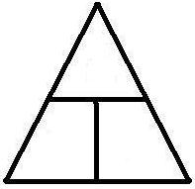
- Formula:

- F____________________________
- M____________________________
- A_____________________________
Force Example Problems
- How much force is needed to accelerate a 500.0 kg car at a rate of 4.000 m/s/s?

- A 50kg object is accelerating at a rate of 2 m/s/s, what is the force that causes this acceleration?

3rd Law of Motion
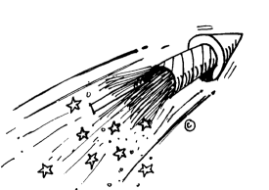
- The Law: For ______________ action there is an _____________ but _______________ reaction.
- Concept: ________________________________________________
- Examples: _______________________________________________
Applying the 3rd Law
- If Rico kicks a ball with 100- N of force, how much force did the ball exert on Rico?

Friction
- A force ___________________________________________________________________
- Allows us _________________________________________________________________
- Lubricants ________________________________________________________________

Types of Friction
Static | Sliding | Rolling | Fluid

Gravity and Free Falling Objects

- Gravity: A force__________________________________________________________
- Acts ________________________________________________________________
- Acceleration_______________________________________________________________

Air Resistance
- Force ____________________________________________________________________

- Factors ___________________________________________________________________

- Acts ____________________________

Gravity and Air Resistance: A Relationship
- They are _________________________________________________________________

- Gravity ______________________________________

- Air resistance _________________________________

- Follows __________________________________________________

Feather vs Rock

- Earth: _____________________________________________________________
- Why?__________________________________________

- Moon or Vacuum: ________________________________________________________
- Why? ______________________________________________________________

Projectile Motion
- The motion ___________________________________________________________________
- Two Forces
  - __________________________

  - __________________________

- Gravity ____________________________________
- Velocity ____________________________________
- Forms ______________________________________

Gravity and Weight

- Weight—______________________________________
- Formula

- Fg=__________________________________________
- M=_________________
- g=_______________

Weight Example Problems:
- If a 20 kg dude is on Earth, what is his weight?

- A rock on Earth has a weight of 1000 N, what is the rock’s mass?

