**What is Earth Science?**

The _____________ for the group of _________________ that deal with _____________ and its ___________ in space.

**Branches of Earth Science**

MC900323370[1]

A. **Oceanography**: the _____________ of the _________________

EX: ____________________, ______________

MC900232180[1]MC900310876[1] B. **Meteorology**: the _____________ of the ___________________ and the ________________ that produce ________________ and _________________

C. **Astronomy**: the _______________ of the ________________ and ______________

MC900200161[1] D. **Geology:** the ____________ of _______________ that make up _______________________

🡪 **Physical Geology**

🡪 **Historical Geology**

**Environmental Science**

🡪 Used for ______________ that _____________ on the ______________ between ______________ and the natural ______________________

**Resources**

\***Renewable**🡪 _______ be _________________ over relatively ___________ time span

Ex: _______________________________________________________

\***Nonrenewable**🡪 ___________ be replenished ___________(takes ___________ of ____________)

Ex: _______________________________________________________

**Scientific Inquiry**

**Hypothesis**🡪 ____________________________________________________________

MC900241179[1]**Theory**🡪_______________________________________________________________

________________________________________________________________________

**Law**🡪 _________________________________________________________________

**The Science and Engineering Practices**

* Asking _______________ and Defining Problems
* Developing and Using ___________
* Planning and Carrying Out _________________________
* ________________ and Interpreting Data
* Using Mathematics and Computational ____________________
* Constructing Explanations and Designing ________________
* Engaging in Argument from _____________________

Obtaining, Evaluating, and _____________________ Information

MC900329972[1]**Measurements**

* + **Length/distance**🡪 how ___________ something is
    - MC900304769[1]Units: ___________________________________
    - Tools: ___________________________________
  + **Temperature**🡪 how much ___________ an object has
    - MC900318880[1]Units: ___________________________________
    - Tools: ___________________________________
  + **Mass**🡪 how much ___________ is in an ____________
    - Units: ___________________________________
    - Tools: ___________________________________
  + 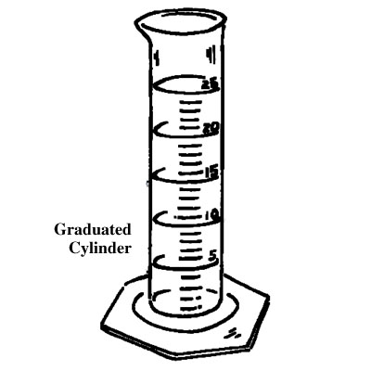**Volume**🡪 how much _____________ an object ____________ up
    - Units: ___________________________________
    - Tools: ___________________________________
      * Volume of Regular object (block): _________________________
      * Volume of liquids: ______________________________________
      * ****Volume of Irregular object (rock): __________________________
  + **Density**🡪 ____________________________
    - Units: ______________________________
    - Formula:

**Maps and Directions**

🡪**Latitude**: distance _____________ or _____________ of the ______________

🡪**Longitude**: distance _____________ or _____________ of the ____________________

**Equator**: 0º _______________, divides _____________ into the _____________ and ______________ hemisphere

**Prime Meridian**: 0º ________________, passes through ______________, England; divides the _____________ into the ______________ and ____________ hemisphere